PRESS RELEASE

PLACE: Primary School and Kindergarten Unit No. 1,
House of Culture MDK and school’s FB website
DATE: 6.05.-31.05.2019
EVENT: The posters and the banners
The linki: https://www.facebook.com/stotrzynastka/, www. sp113.wroc.pl
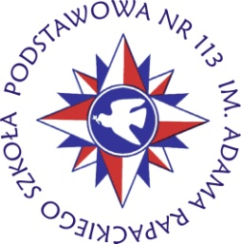

The idea was to inform the school community, the local environment about the Cosmus project and the first short-term pupil exchange.
The posters and the banners are placed in the most visible and attended places. The contents of the banners inform about the main goal, title, organizations and type of the exchange.
Every day,the students and the parents could observe and see a lot of informations about Cosmus project placed in the banners and in the posters.
The bags with logo were also a good idea to disseminate our project. The logo of project was visible in our school, in the corridors, on the front wall of our school .
The children of our school prepared a large number of flowers in the colors of parnetrs' flags and teachers placed them in the school's corridors, doors, walls. Thanks to that, everyone could get acquainted with the main idea of project. Our school became a source of information about Cosmus Project. Everything was documented in school website, in the school Facebook. We could observe a lot of positive comments in the Facebook, opinions, support on the part of parents and interest on the part of pupils. The banners, the posters and the flowers represented partners' countries became a sort of project's exhibition visible for whole community.
The main goal of exhibition was to present the main idea of project, of collaboration with other countries, teachers and tutors. The objects were also presented in the main corridors of House of Culture.

